**ADVANTAGES AND DISADVANTAGES**

1. **In some countries young people are encouraged to work or travel for a year between finishing high school and starting university studies. Discuss the advantages and disadvantages for young people who decided to do this.**
2. A lot of places in the world rely on tourism as a main source of income. Unfortunately, tourism can also be a source of problems if it is not managed correctly. Describe the **advantages and disadvantages** of tourism in the modern world.
3. Template 1:
4. Introduction: **It is believed that** (viết lại đề)**. I believe that this opinion/ trend/ concept has its own merits and demerits.**
5. Body:

* Body 1: **It is clear that** **this idea is advantageous in some ways**. **One of the benefits is that** thuận lợi 1. Ý lập luận 1. **Another benefit would be that** thuận lợi 2. Ý lập luận 2.
* Body 2: **Nevertheless, there are drawbacks to such a trend**. **First and foremost,** bất lợi 1. Ý lập luận 1. **In addition,** bất lợi 2. Ý lập luận 2.

1. Conclusion: **In conclusion,** (paraphrase chủ đề của bài) **could bring about certain benefits, but its negative consequences should not be forgotten.**

**ADVANTAGES AND DISADVANTAGES**

1. **EXAMPLE**
2. Some people regard video games as harmless fun, or even as a useful educational tool. Others, however, believe that videos games are having an **adverse effect** on the people who play them.

In your opinion, do the drawbacks of video games **outweigh** the benefits?

1. **TEMPLATE**
2. Template 1:
3. Introduction: **It is believed that** paraphrase đề. ***While I accept that*** *trend/ concept* **has some positive effects/ harmful impacts*,*** I believe that it is more likely to have a number of **harmful impacts/** **positive effects**
4. Body:

* Body 1: **On the one hand,** **the concept** **is beneficial/ disadvantageous in some ways.** **One of the first benefits/ drawbacks is that** thuận lợi/ bất lợi 1. Ý lập luận. **Another benefit/ drawback would be that** thuận lợi/ bất lợi 2. Ý lập luận
* Body 2:

Phân tích bất lợi: **On the other hand, I would argue that these benefits are outweighed by the drawbacks.**

Phân tích thuận lợi nhiều hơn: **On the other hand, I would argue that these drawbacks are outweighed by the benefits.**

**First and foremost,** thuận lợi/ bất lợi 1. Ý lập luận. **In addition,** thuận lợi/ bất lợi 2. Ý lập luận.

1. Conclusion:

**Bất lợi nhiều hơn: In conclusion, it seems to me that the potential dangers of** chủ đề của bài **are more significant than the possible benefits.**

**Thuận lợi nhiều hơn: In conclusion, it seems to me that the potential benefits of** chủ đềcủa bài **are more significant than the possible disadvantages.**

**ARGUMENTATIVE ESSAY**

1. **EXAMPLE**
2. Some people believe that the fast pace and stress of modern life is having a negative effect on families. **To what extend** do you agree or disagree?
3. Many people think that **modern communication technology is having some negative effects on social relationship**. Do you agree or disagree?
4. **TEMPLATE**
5. Template 1:
6. Introduction: **It is believed that** paraphrase lại đề**. I totally agree/disagree with this opinion because of the two following reasons.**
7. Body

* Body 1: **First and foremost, I would argue that** ý chính 1. **This is because**, đưa nguyên nhân. **In fact,** thực trạng. **For instance,** lấy ví dụ. **As a result,** kết quả.
* Body 2: **Another point to mention is that** ý chính 2. **The reason is that** giải thích. **To cite an example,** ví dụ. **As a result**, kết quả. **Additionally,** ý giải thích.

1. Conclusion: **In conclusion, as the two analyzed reasons above, I strongly agree/disagree with the idea that** paraphrase topic.

**DISCUSS BOTH VIEWS**

1. **EXAMPLE**
2. Several languages are in danger of extinction because they are spoken by very small numbers of people. Some people say that governments should **spend public money on saving these languages**, while others believe that would **be a waste of money**.

Discuss both these views and give your opinion.

1. Some people believe that there should be the death penalty for extremely serious crimes. Others believe that it is not morally correct to kill criminals.

Discuss both these views and give your own opinion.

1. Template 1:
2. Introduction: Giới thiệu topic. **Some people hold the view that** quan điểm A, **while others opine that** quan điểm B. **In this essay, I am going to examine this question from both points of view and then give my own opinion on the matter.**
3. Body

* Body 1: **There are several reasons why** (viết lại quan điểm A). **First and foremost,** ý chính 1. Ý hỗ trợ. **Another reason is that** ý chính 2. Hỗ trợ luận điểm 2.
* Body 2: **Despite the above arguments,** **I believe that** viết lại quan điểm B. **Firstly,** ý chính 1. Ý hỗ trợ. **Secondly,** ý chính 2. Ý hỗ trợ.

1. Conclusion: ***In conclusion, I believe both arguments have their merits.******On balance, however, I feel that*** *paraphrase lại quan điểm B.*

**PROBLEMS – SOLUTIONS**

In many countries, the average life expectancy has been increasing. What problems will this cause for individuals and for society as a whole? Suggest some solutions.

Template:

1. Introduction: **It is true that** (paraphrase đề). **In this essay, I intend to explore the issues caused by this trend/ phenomenon and offer some effective solutions as well.**
2. Body

* Body 1: **There are several problems associated with it**. **To begin with,** hậu quả 1. Ý hỗ trợ. **The second issue is that** hậu quả 2. Ý hỗ trợ 2
* Body 2: **Given the above issues, there are some solutions to help get rid of the problems**. **The first solution is that** giải pháp 1**. Therefore**, hiệu quả của giải pháp 1. **Another solution is that,** giải pháp 2. **As a result,** hiệu quả của giải pháp 2

1. Conclusion: **In sum,** chủ thể của đề **has caused a wide range of problems; therefore, we should take several measures to address those (worrying) issues.**

**CAUSE – SOLUTION**

Template:

1. Introduction: **It is true that** (viết lại đề). **In this essay, reasons for this phenomenon/ trend/ issue will be analyzed and relevant solutions will be provided as well.**
2. Body

* Body 1: **There are several causes of this issue**. **First and foremost**, nguyên nhân 1. Giải thích nguyên nhân 1. **Moreover,** nguyên nhân 2. Giải thích nguyên nhân 2.
* Body 2: **On the basis of the above reasoning, some solutions have been identified.** **The first solution is that** giải pháp 1. **It is evident that** hiệu quả của giải pháp 1. **Another solution is that** giải pháp 2. **As a result,** hiệu quả của giải pháp 2.

1. Conclusion: **To sum up, due to the serious reasons why** (viết lại đề), **I firmly believe some measures must be taken to address these problems.**

In some countries, there is not enough respect for elderly people. Why is this the case? Suggest some solutions.

**CAUSE - EFFECT**

Template:

1. Introduction: **It is true that** viết lại đề. **This essay will discuss some reasons why this has occurred and the consequences of this worrying trend.**
2. Body:

* Body 1: **There are several causes of this issue**. **First and foremost**, nguyên nhân 1. Giải thích nguyên nhân 1. **Moreover,** nguyên nhân 2. Giải thích nguyên nhân 2.
* Body 2: **On the other hands, the effects of this issue are very obvious.** **To begin with,** hậu quả 1. Ý lập luận. **Also,** hậu quả 2. Ý lập luận.

1. Conclusion: **To sum up, there are the serious reasons why** (viết lại đề), **consequently, they have caused a wide range of problems.**

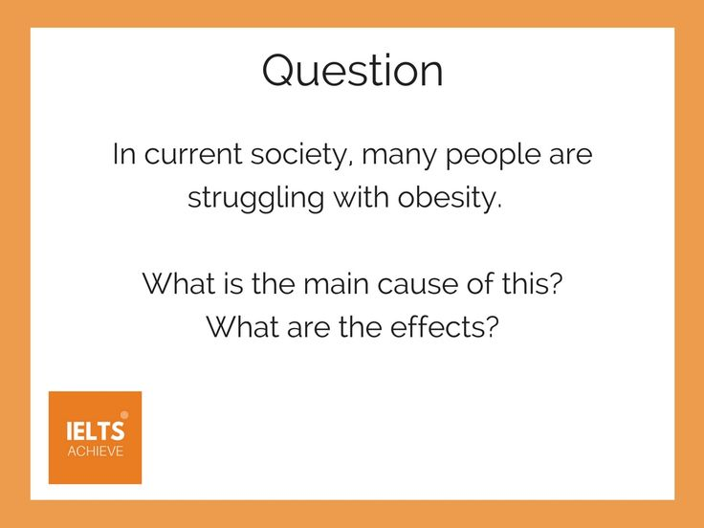

**E: Two-part Question**

Đối với dạng bài này, thông thường có hai câu riêng biệt được đưa ra và hầu hết các câu hỏi thường được bắt đầu bằng Wh-question (từ để hỏi).

Ví dụ:

*Happiness is considered very important in life.*

*Why is it difficult to define?*

*What factors are important in achieving happiness?*

***Mở bài:***

*Câu 1. Viết lại đề.*

*Câu 2. Trả lời câu hỏi*

***Many people believe that happiness plays an inevitably important role in our life.******The term is hard to identify because of some reasons****, and* ***there are some aspects to attain the happiness in life.***

*Thân bài*

*Body 1: Trả lời câu 1*

*Câu 1.* ***It is quite hard to identify the true meaning of happiness because of 2 reasons****. Idea 1 support 1 idea 2 support idea 2*

*Body 2: Trả lời câu 2*

*Câu 1.* ***To attain the happiness, several factors should be taken into consideration****. Idea 1 – support 1 – idea 2 – support 2*

***Kết luận***

*In conclusion, viết lại đề bài và trả lời lại câu hỏi.*